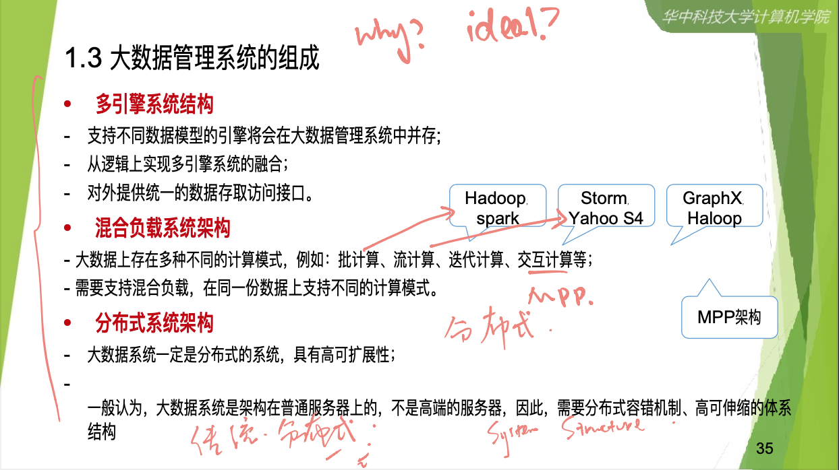

批计算 batch computing

Adhoc, scheduled systems, collection of data HDFS

流计算 stream processing

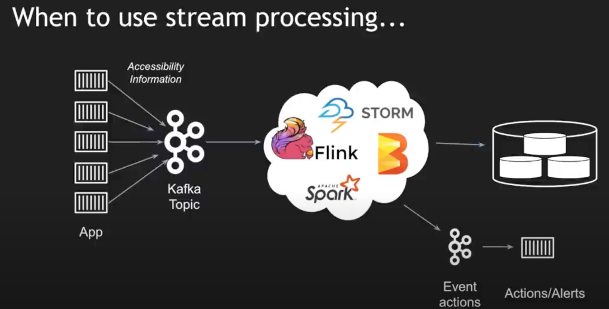 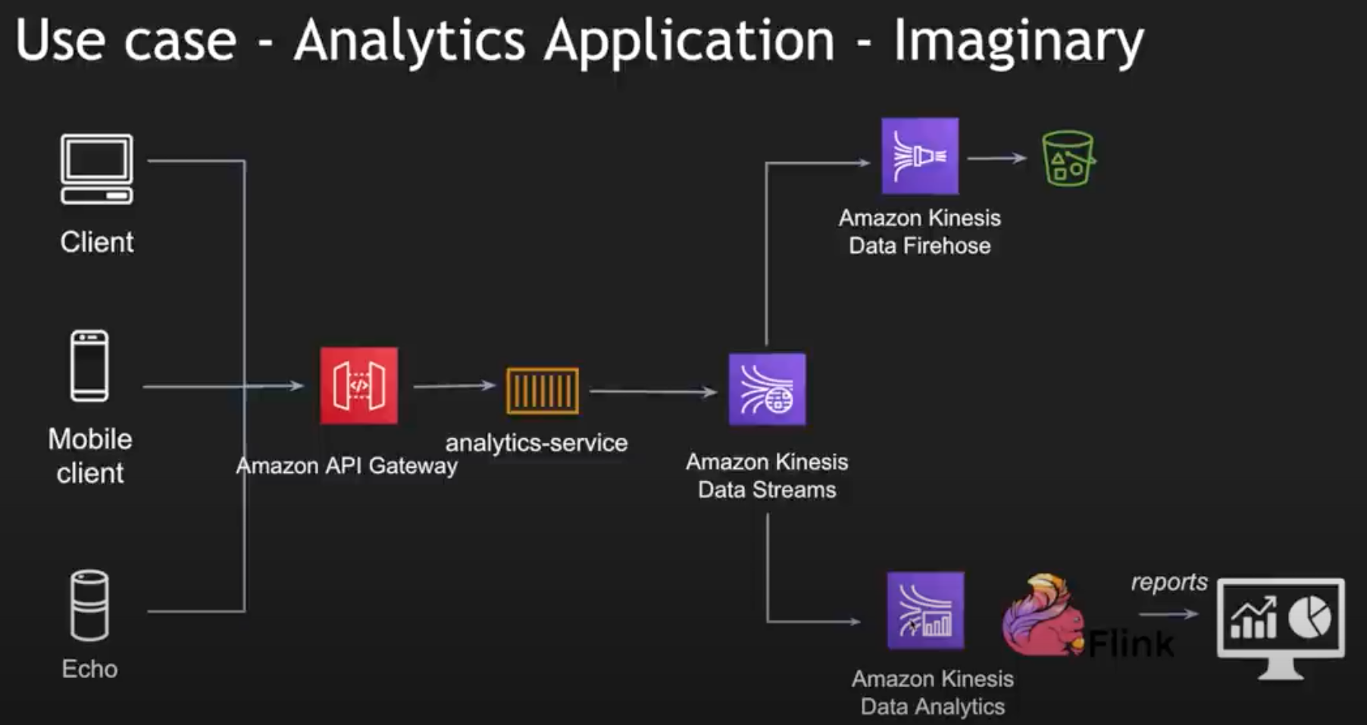

Realtime, continuous

迭代计算 iterative computations

交互计算Interactive computing

<https://www.cnblogs.com/duanxz/p/12610999.html>

<https://blog.csdn.net/woshiwanxin102213/article/details/19990487>

对于云计算或者排序都要有适合于自己的引擎结构适合于自己的处理过程。。这个是理想状态下的多引擎 并存。他是有一个因果关系的。这个在系统组成上有什么特点。分析问题出在哪里?负载hadoop storm 迭代计算 基本的思想还有一个就是分布式的。大数据系统的分布式和数据传统的分布。出发点是不一样 的，他这里的最大的变化是。机群架构在主通服务器上面而不是传统的高性能的。所以他的分布式是松散 耦合还有一个容错。伸缩性会比较好。他的系统组成有什么特点?归纳问题表现在什么层面?解决这个问 题，我们需要采用什么样的技术手段?某某数据，点集数据社交网络关系。这样的系统他最适合于什么样 的结构?keyvalue还是文档还是如果你用途数据的话，你的系统引擎会怎么选?你会选择哪些放在你的系 统平台里面去。为什么你要选择这些?选一个够不够?因为现在大家去处理的话，肯定都是混合式的。选 一个肯定不够。假如让你去做一个系统架构，选择一个什么样的软件和硬件来设计这个环境。

第一章

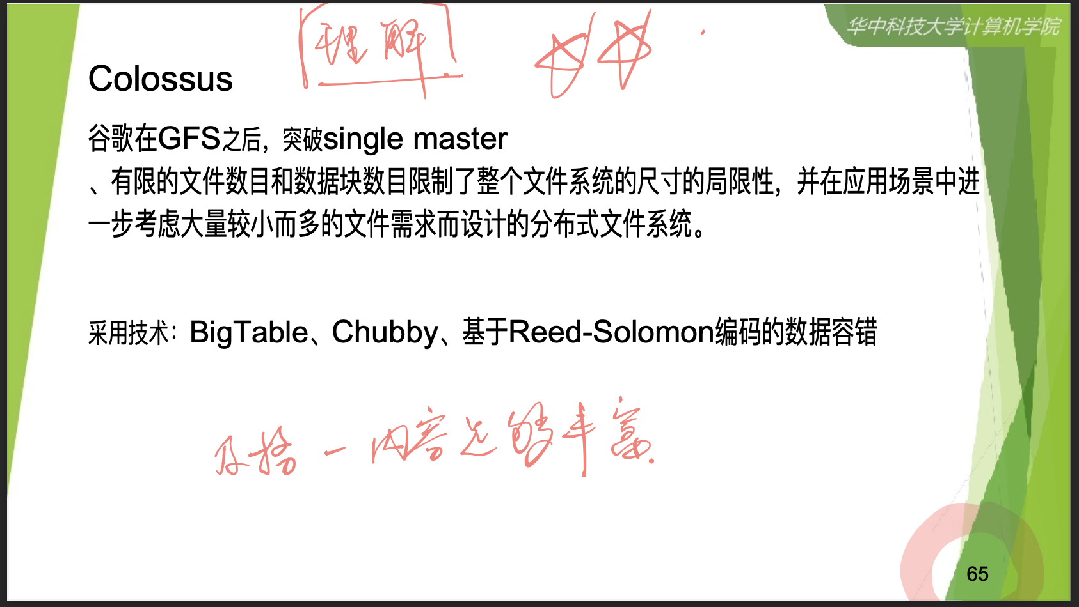

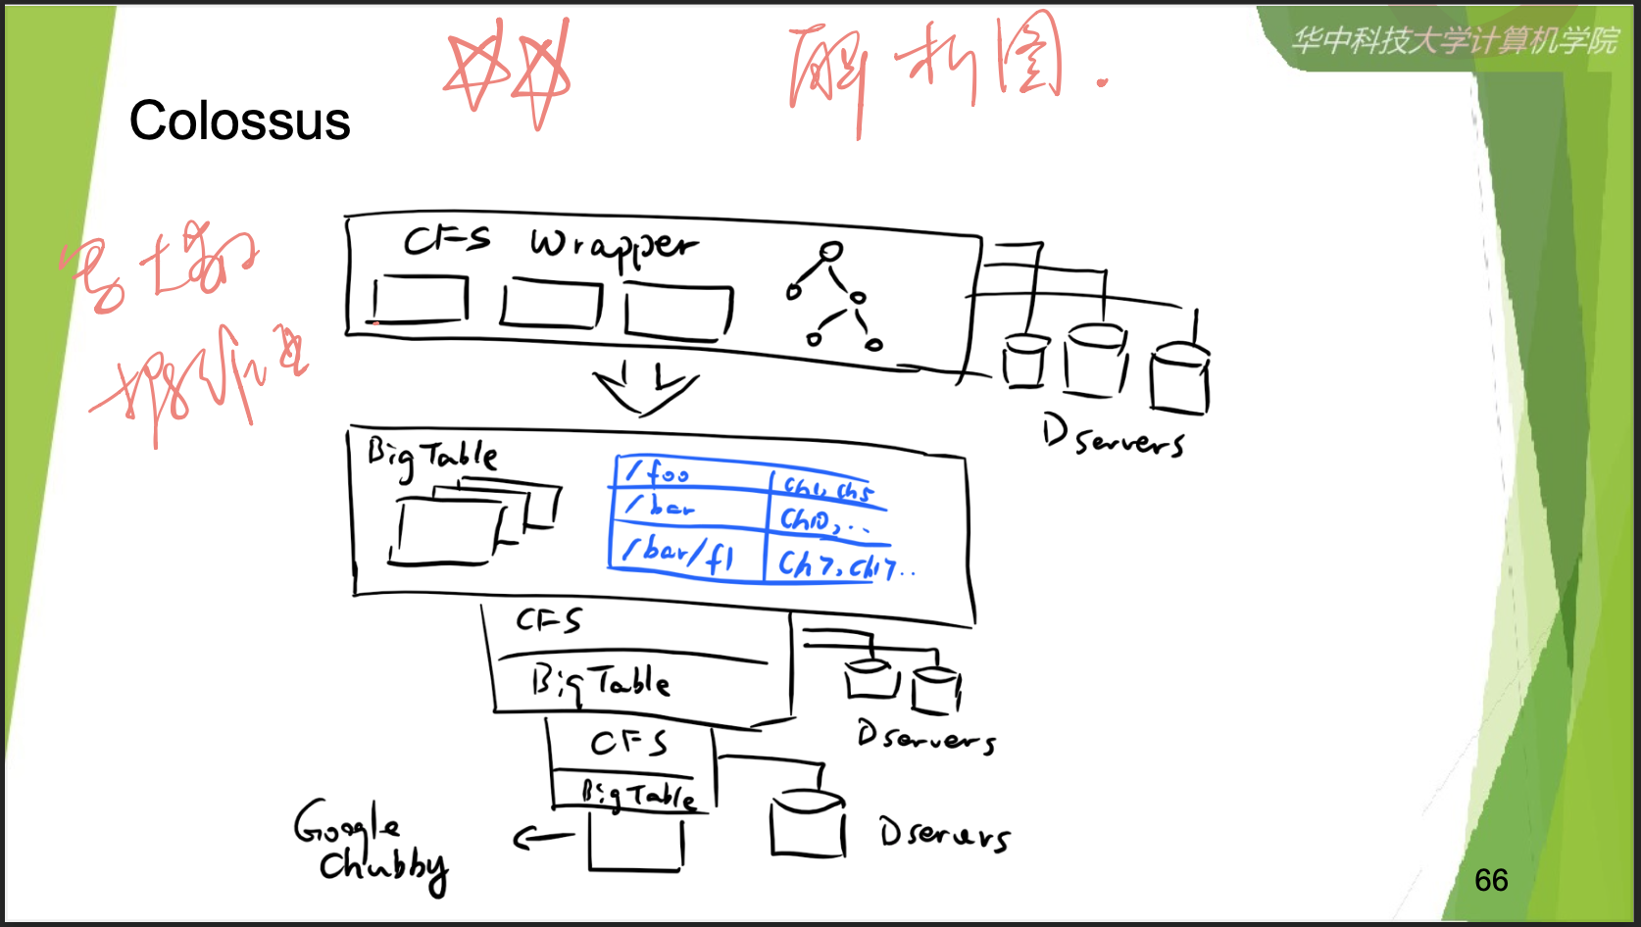

Google **Bigtable** is a distributed, column-oriented data store created by Google Inc. to handle very large amounts of structured data associated with the company's Internet search and Web services operations. ... Nevertheless, **Bigtable** has had a large impact on NoSQL **database** design.

**Bigtable** is ideal for applications that need very high throughput and scalability for key/value data, where each value is typically no larger than 10 MB. **Bigtable** also excels as a storage engine for batch MapReduce operations, stream processing/analytics, and machine-learning applications.

Bigtable is a distributed storage system (built by **Google**) for managing structured data that is designed to scale to a very large size: petabytes of data across thousands of commodity servers. Many projects at **Google** store data in Bigtable, including web indexing, **Google** Earth, and **Google** Finance.

**Chubby** is a highly available and persistent distributed lock service and file system created by **Google** and used in various projects and frameworks, including Bigtable and MapReduce. ... The key design goal of **Chubby** was high availability and high reliability.

Google has developed **Chubby**, a lock service for loosely coupled distributed systems. It is designed for coarse-grained locking and also provides a limited but reliable distributed file system. ... Though **Chubby** was designed as a lock service, it is now heavily used inside Google as a name server, supplanting DNS.

**Bigtable** relies on a highly-available and persistent distributed lock **service** called **Chubby** [8]. A **Chubby service** consists of five active replicas, one of which is elected to be the master and actively serve requests. The **service** is live when a majority of the replicas are running and can communicate with each other.

This paper describes a lock service called **Chubby**. It is intended for use within a loosely-**coupled distributed** sys- tem consisting of moderately large numbers of small ma- chines connected by a high-speed network.

Reed–Solomon codes are a group of error-correcting codes that were introduced by Irving S. Reed and Gustave Solomon in 1960. ... Reed–Solomon codes operate on a block of data treated as a set of finite-field elements called symbols. Reed–Solomon codes are able to detect and correct multiple symbol errors.

**Colossus** is our cluster-level file system, successor to the **Google** File System (GFS). Spanner is our globally-consistent, scalable relational database. Borg is a scalable job scheduler that launches everything from compute to storage services.2021年4月19日

**Colossus** is our cluster-level file system, successor to the **Google** File System (GFS). Spanner is our globally-consistent, scalable relational database. Borg is a scalable job scheduler that launches everything from compute to storage services.

<https://www.programmersought.com/article/7842127110/>

<https://cloud.google.com/blog/products/storage-data-transfer/a-peek-behind-colossus-googles-file-system>

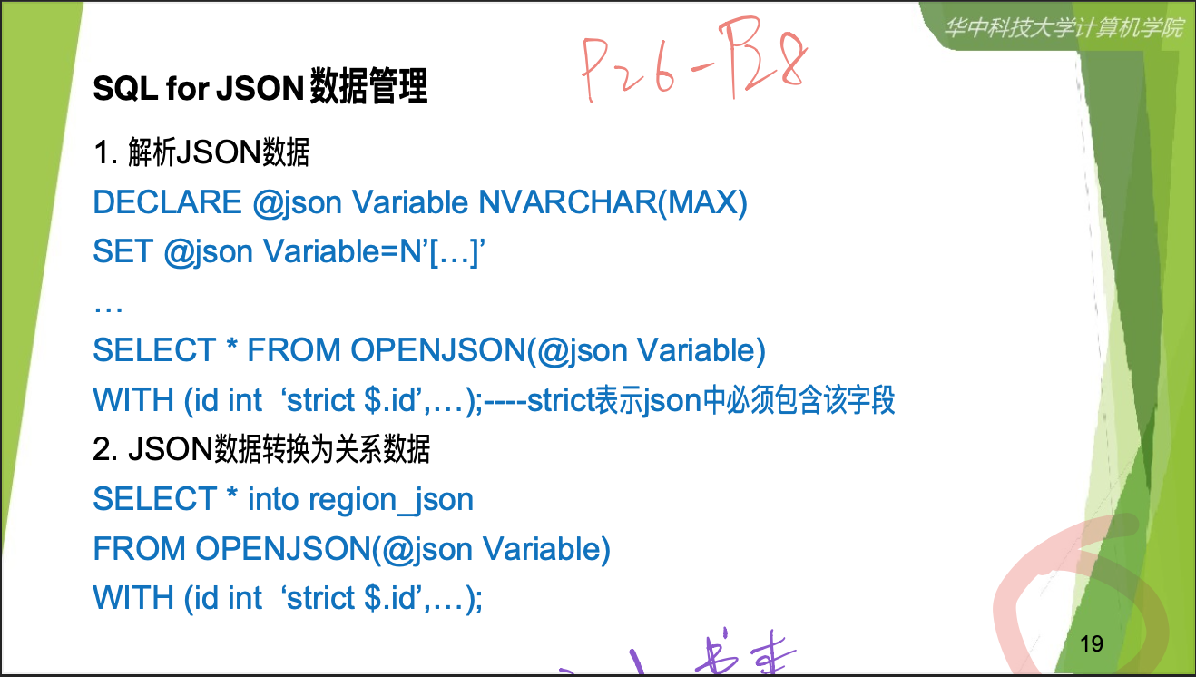

J son documentations

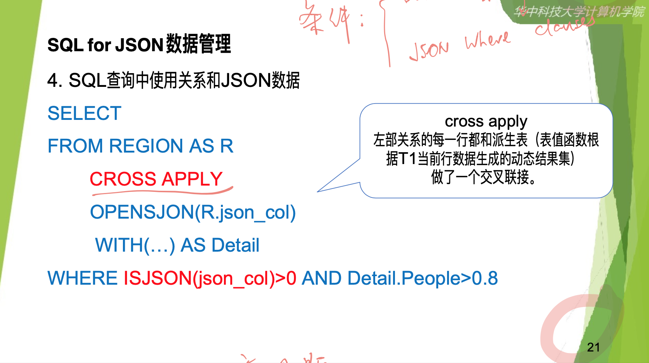

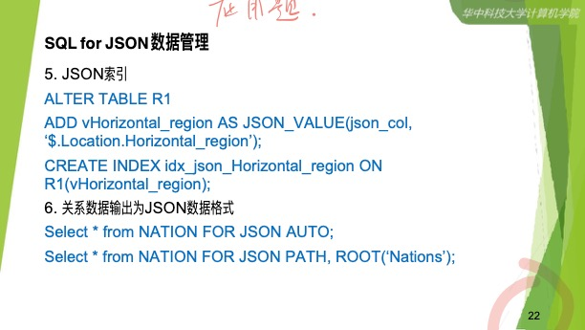

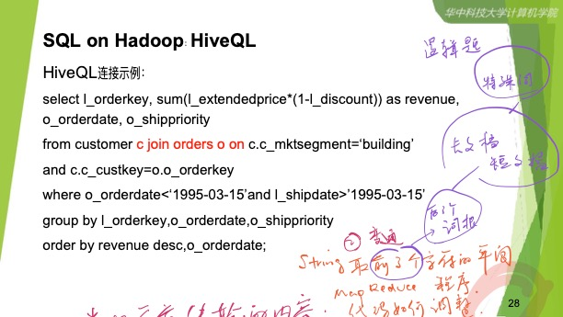

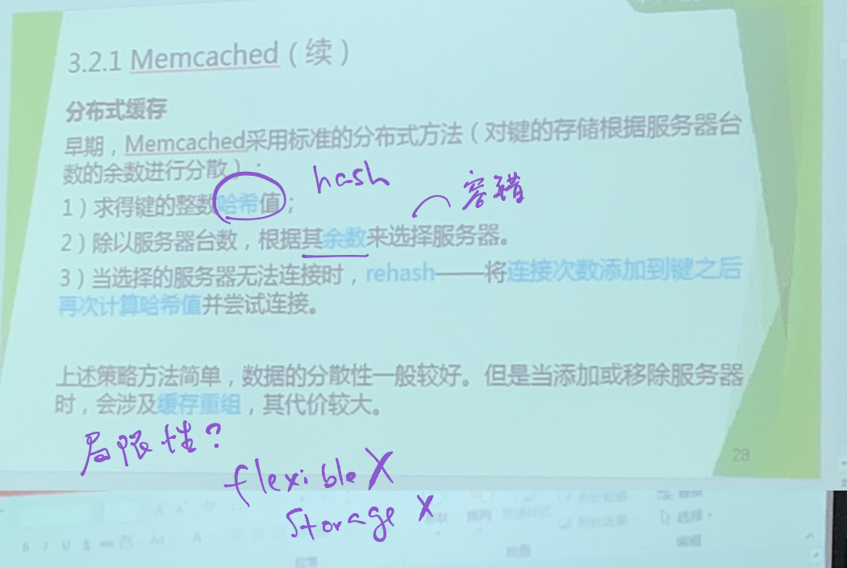

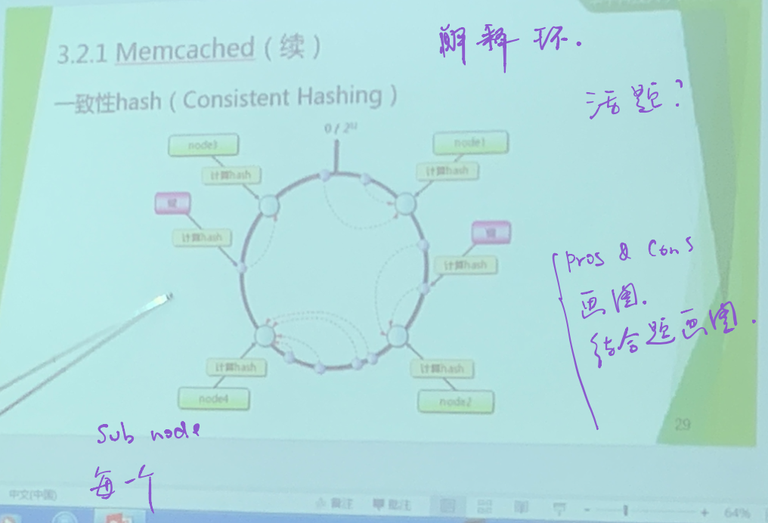 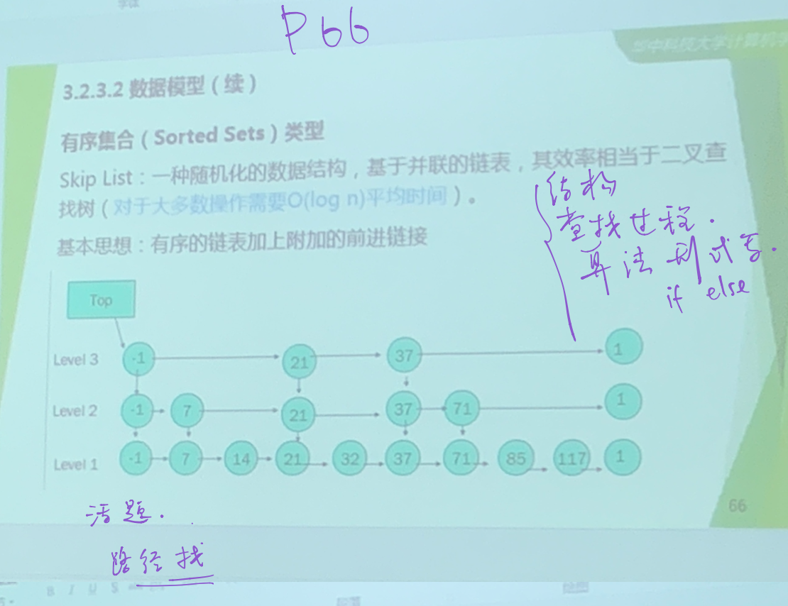 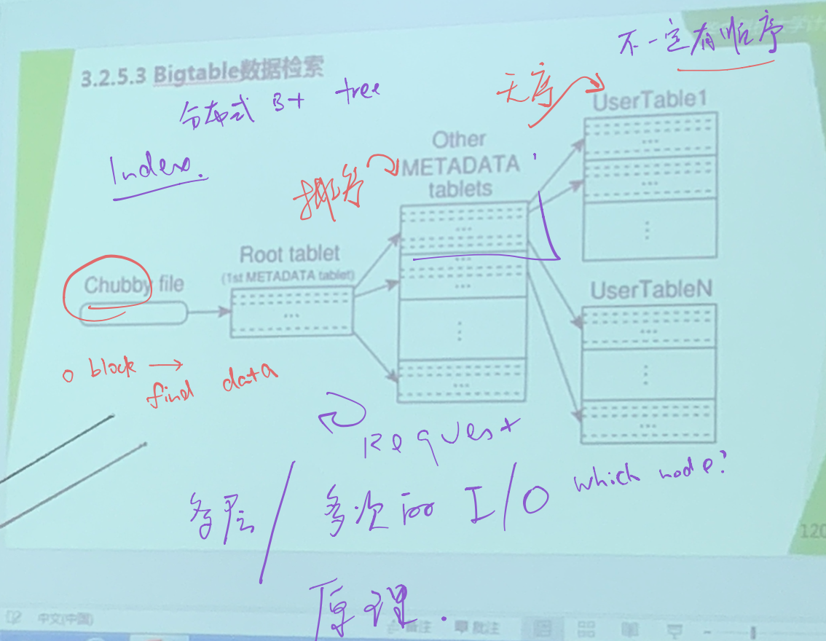

数据如何分布的问题? 标准的早期的分布。考虑了索引和负载均衡不能直接把哈⻄函数的输出值。用到这个上面。他用到的是求 余数的方法。还有一个容错的任务。早期的memcached也是有策略的。不是简单的，一个运算，中间还 是有一个哈希算法。

但是这个还是会有一个局限性的，你要明白这个局限性是在什么地方。主要还是秋余数的话，导致他的伸

缩性不行。储存的代价太高，所以换用了一次性哈⻄。大家要吧一次性哈⻄。用这个图把它描述出来。为

什么是一个环这个环代表了什么含义?数据，节点在这个还上面如何去体现?为什么比前面的方法要好好

在什么地方。

活题  
地址空间 哈希函数 节点编号，每一个数据的姿态应该归属到第几个节点上。可以算出来

如果我们不用一次性哈⻄。前面也是可以考题目的。能够简单地分析它的好坏还有画图。图片要能够表示

清楚。结合题目，再把题目的图片画出来。简单抽象的示意图。

skip list数据查找的过程。用算法写出来 loop if else 给出一个图片，然后让你找节点。按照程序的过程你怎么样才能找到。最后有没有找到，不管有没有找到 你的路径经过了哪些节点?

bigtable  
排序不一定策略复杂性 排序是为了找到metadata每一个table值放在哪个节点上有序列

缓存为什么一次可以缓存多个?

从原理上把它弄懂。

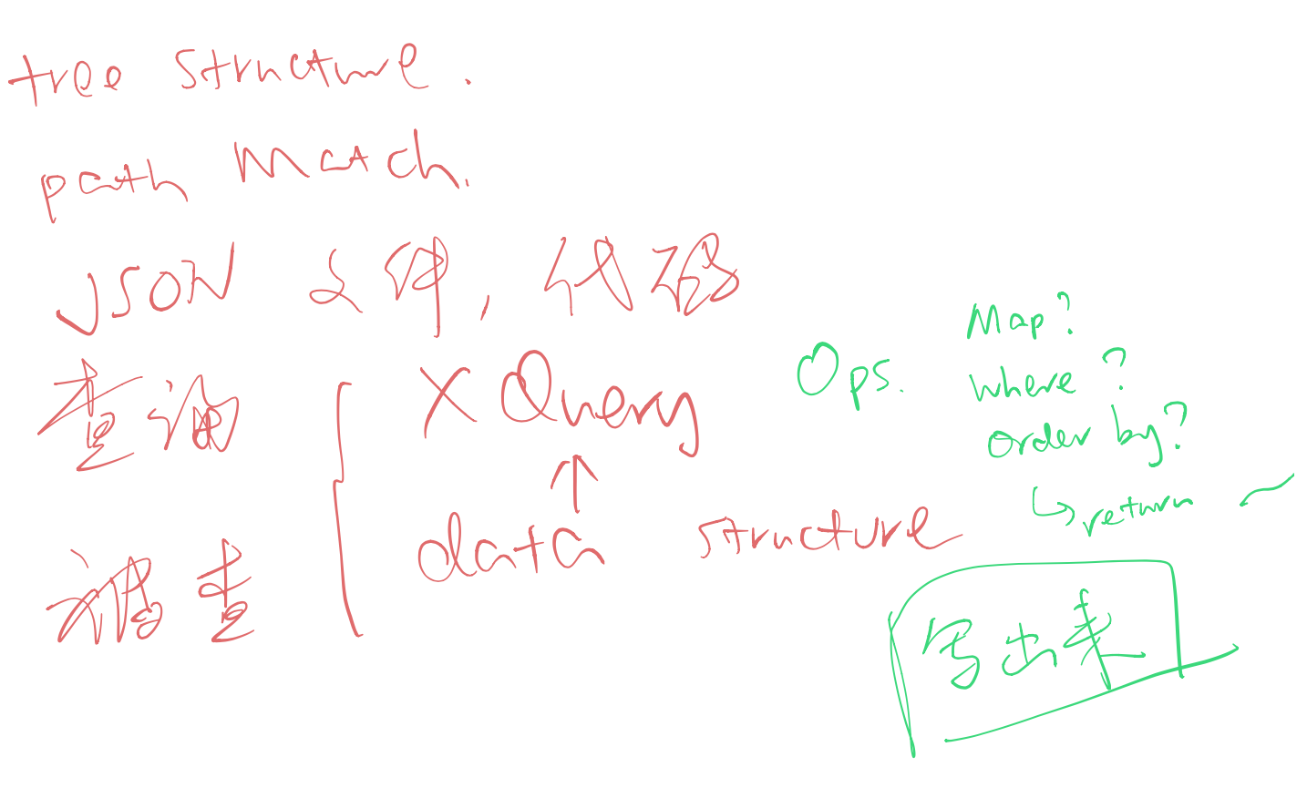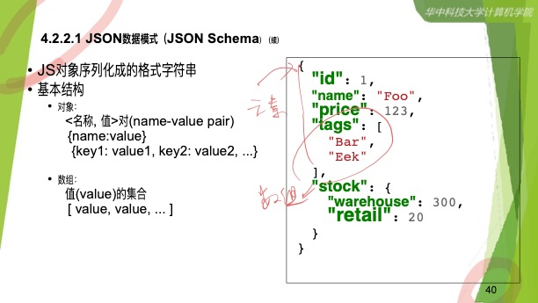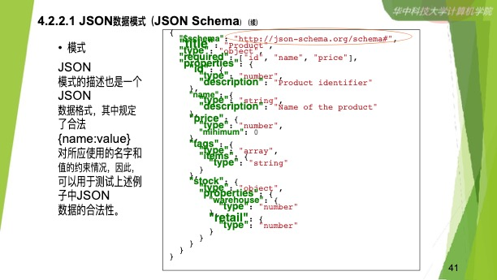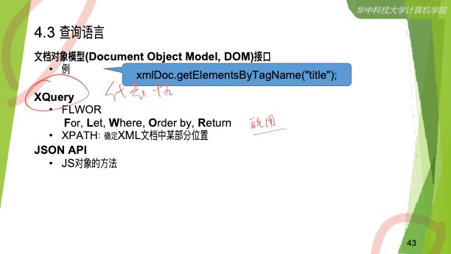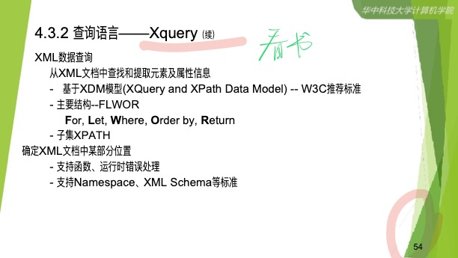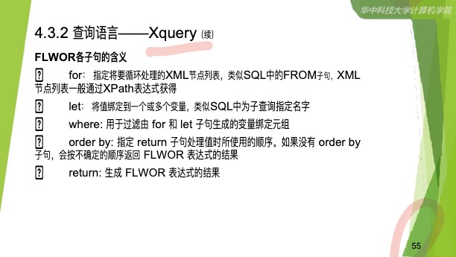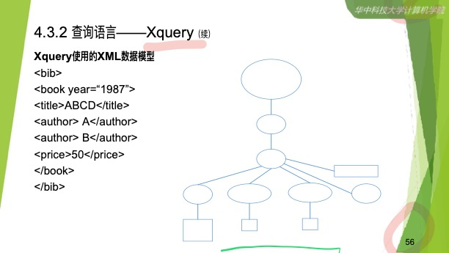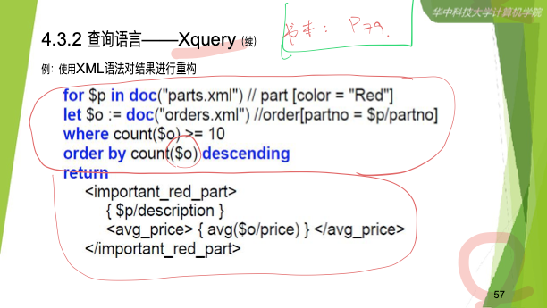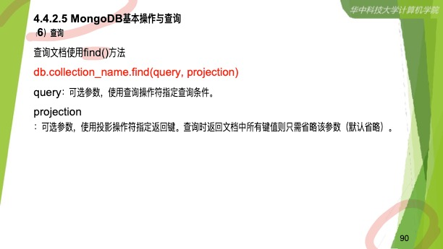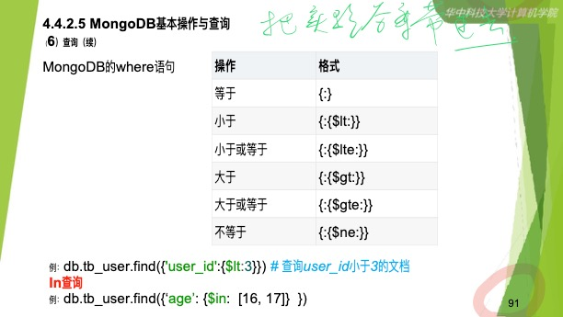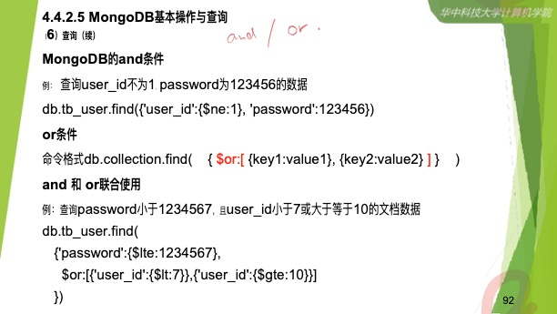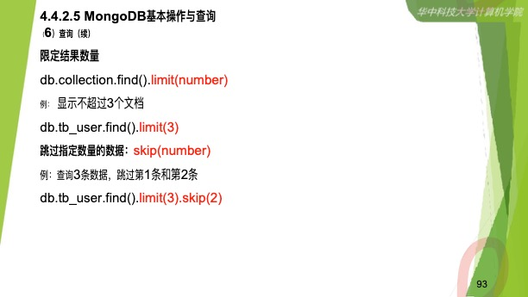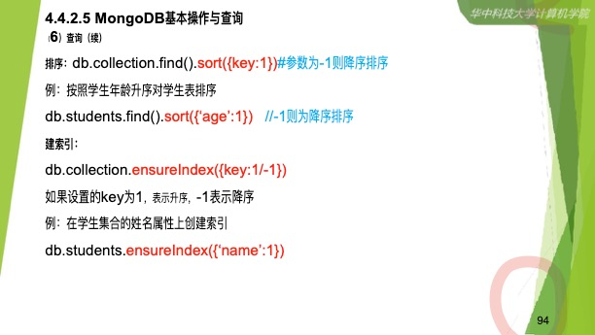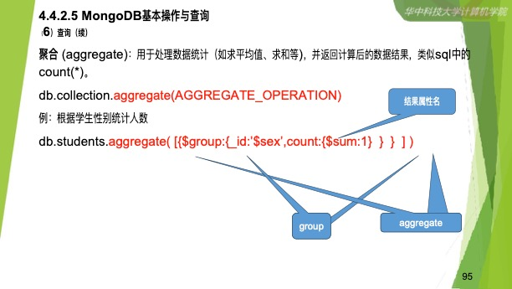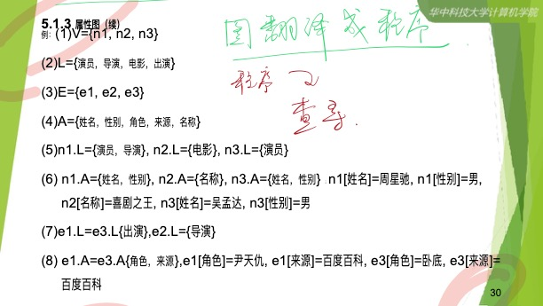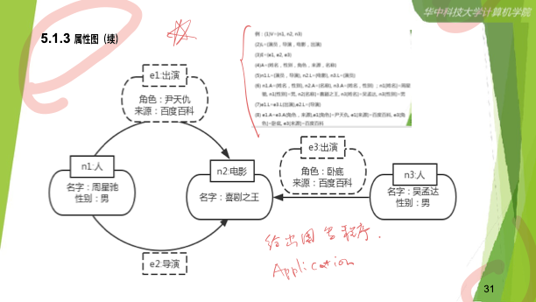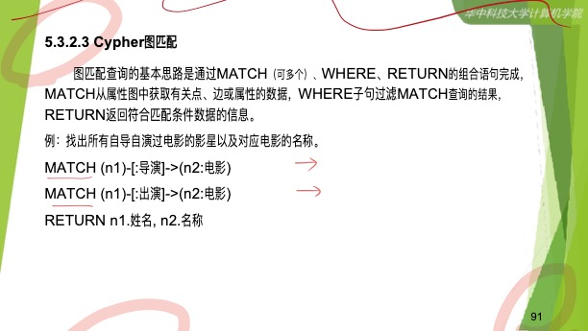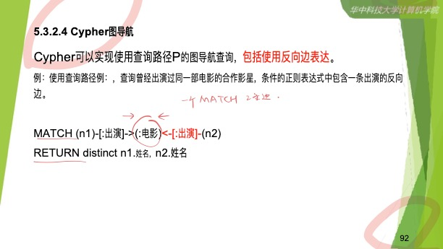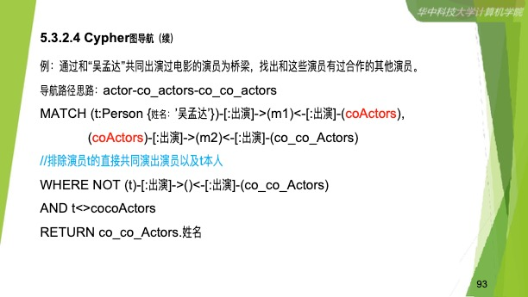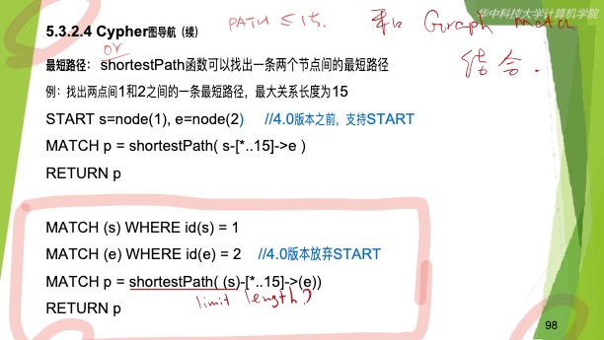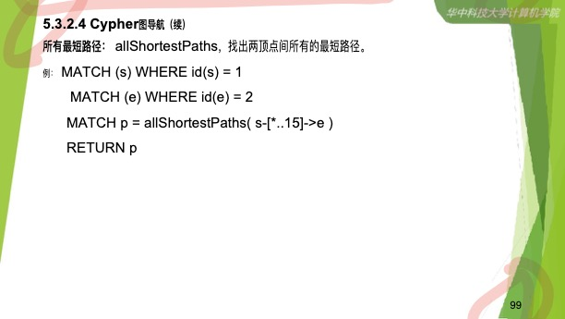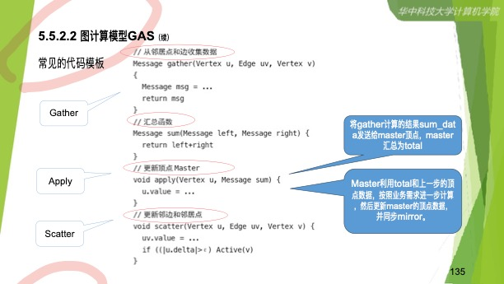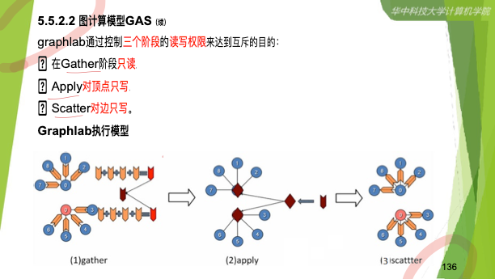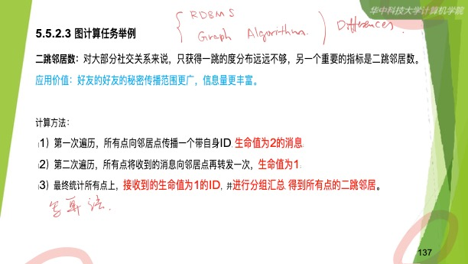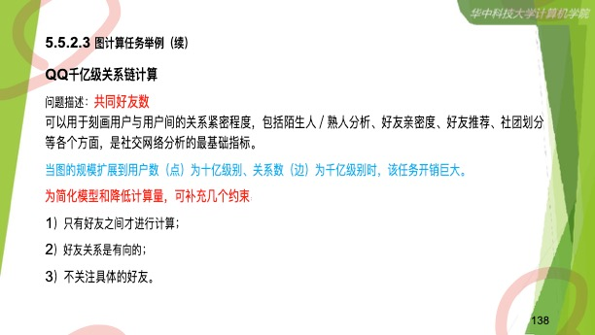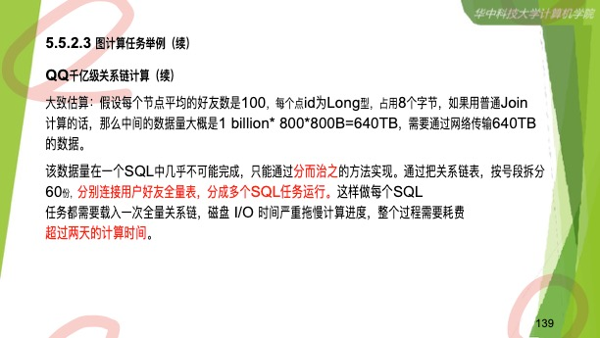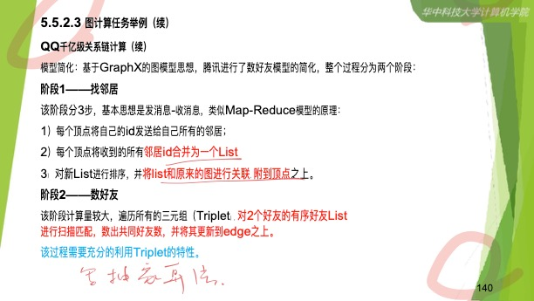

Xquery

<https://www.w3schools.com/xml/xquery_example.asp>

<https://www.w3schools.com/xml/xml_dom.asp>